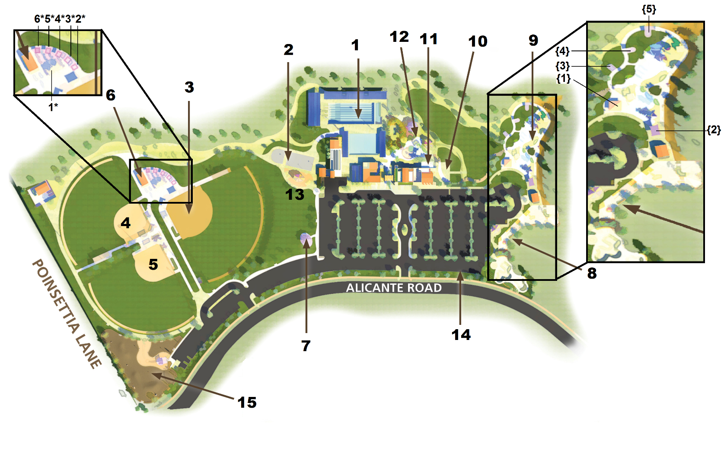**Alga Norte Park**

**Picnic Areas**

Covered Pavilion Large (Pool) 1*- Picnic Area: Ball Field Large (4) {1} - Picnic Area #1 Tot Lot (4)

Covered Pavilion Medium (Pool) 2*- Picnic Area #2 Ball Field (1) {2} - Picnic Area #2 Tot Lot (2)

Open Space #1 3*- Picnic Area #3 Ball Field (1) {3} - Picnic Area #3 Tot Lot (1)

Open Space #2 4*- Picnic Area #4 Ball Field (1) {4} - Picnic Area #4 Tot Lot (1)

7 - Picnic Area: Overlook (8) 5*- Picnic Area #5 Ball Field (1) {5} - Picnic Area #5 Tot Lot (1)

13 - Picnic Area: Basketball Area (4) 6*- Picnic Area #5 Ball Field (1) 8 - Picnic Area: Skate Park

1 – Pool

2 – Basketball Courts

3 – Baseball Field #1

4 – Baseball Field #2

5 – Baseball Field #3

6 – Concessions

8 – Skate Park

9 – Tot Lot

10 – Private Party Area

11 – Concessions

12 – Splash Area

14 – Parking Lot

15 – Dog Park

**Alga Norte Legend**